

**Bachelor of Information Technology – InfoTech**

**School of Information Technology**

***IT6x30 – Internet Application Development***

**Assignment 1**

**TEAM B**

Student ID: 20700045, 21600252, 21600681

Semester 1, 2018

***Internet application***

***Business Type:***Purchasable Online Based Video Game.

***Product Name:*** 8 Bit Game

***Reason for development:*** Common interest in the video game industry within our group.

***Appropriate methodology***

Figure 1 - ***Agile Methodology***

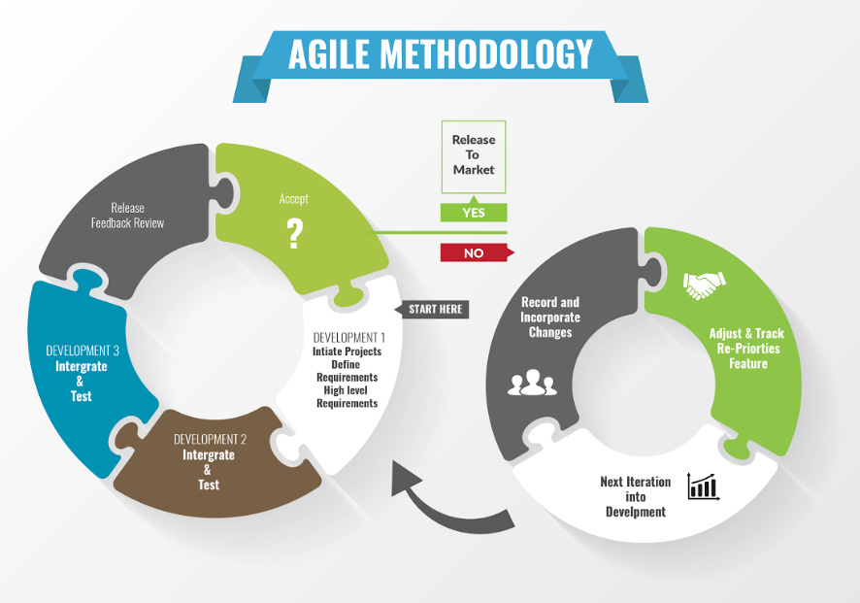

We chose Agile Methodology for its versatile arranging, transformative advancement, early conveyance, and persistent change, and it empowers fast and adaptable reaction to change.

***Usability test***

***Brief description***: Usability testing refers to evaluating a product or service by testing it with representative users.

|  |  |  |  |  |  |
| --- | --- | --- | --- | --- | --- |
| Usability Test | | | | | |
| Item No. | **Test Item** | **Yes** | **No** | **N/A** | **Comments** |
| 1. | **The Website looks appealing.** |  |  |  |  |
| 1a. | Navigation menu |  |  |  |
| 1b. | Home Page |  |  |  |
| 1c. | News Page |  |  |  |
| 1d. | Account Page |  |  |  |
| 1e. | Log in Page |  |  |  |
| 1f. | Register Page |  |  |  |
| 1g. | Buy Now Page |  |  |  |
| 1h. | Admin Panel |  |  |  |
| 2. | **The Website is simple to navigate.** |  |  |  |  |
| 2a. | Navigation menu |  |  |  |
| 2b. | Account Page |  |  |  |
| 2c. | Log in Page |  |  |  |
| 2d. | Home page |  |  |  |
| 2e. | Register Page |  |  |  |
| 2f. | Buy now page |  |  |  |
| 2g. | New page |  |  |  |
| 2h. | Admin Panel |  |  |  |
| 3. | **Navigation bar is consistent on every page.** |  |  |  |  |
| 3a. | Home Page |  |  |  |
| 3b. | News Page |  |  |  |
| 3c. | Account Page |  |  |  |
| 3d. | Log-in Page |  |  |  |
| 3e. | Register Page |  |  |  |
| 3f. | Buy Now Page |  |  |  |
| 3g. | Admins Panel |  |  |  |
| 4. | **Text on each page is clear and easy to understand.** |  |  |  |  |
| 4a. | Home Page |  |  |  |
| 4b. | News Page |  |  |  |
| 4c. | Accounts Page |  |  |  |
| 4d. | Log-in Page |  |  |  |
| 4e. | Buy Now Page |  |  |  |
| 4f. | Register Page |  |  |  |
| 4g. | Admin Panel |  |  |  |
| 5. | **The Website was informative of its purpose.** |  |  |  |  |
| 5a. | Home page was informative about the developers |  |  |  |
| 5b. | News Page was informative about upcoming events and news |  |  |  |
| 6. | **Navigation bar links are functional and take me to the correct place.** |  |  |  |  |
| 6a. | Home Page |  |  |  |  |
| 6b. | News Page |  |  |  |  |
| 6c. | Log-In Page |  |  |  |  |
| 6d. | Register Page |  |  |  |  |
| 6e. | Account Page |  |  |  |  |
| 6f. | Buy now page |  |  |  |  |
| 7. | **Forms contain all required fields to fill out.** |  |  |  |  |
| 7a. | Log in page contains necessary form fields. |  |  |  |
| 7b. | Register page contains necessary form fields. |  |  |  |
| 7c. | Buy Now page contains necessary form fields. |  |  |  |
| 8. | **The website displays the expected pages required for its needs.** |  |  |  |  |
| 8a. | Home page |  |  |  |
| 8b. | News page |  |  |  |
| 8c. | Buy now page |  |  |  |
| 8d. | Register Page |  |  |  |
| 8e. | Account page |  |  |  |
| 9. | **All forms can be completed and submitted successfully.** |  |  |  |  |
| 9a. | Register form |  |  |  |
| 9b | Buy Now Form |  |  |  |
| 9c | Log in form |  |  |  |
| 10. | **Goals of the website look to have be achieved.** |  |  |  |  |
| 11. | **I would revisit this website for further use.** |  |  |  |  |
| 12. | **Shop items priced fairly and labelled clearly.** |  |  |  |  |
| 12a. | 8-Bit Game |  |  |  |
| 13. | **Clickable buttons are obvious.** |  |  |  |  |
| 13a. | Buy Now button |  |  |  |
| 13b. | Upload image |  |  |  |
| 13c. | Log out button |  |  |  |
| 13d. | Sign up button |  |  |  |
| 14. | **Information gathered from the user is relevant.** |  |  |  |  |
| 14a. | Register form information |  |  |  |
| 14b. | Buy now form information |  |  |  |
| 14c. | Log in form information |  |  |  |

***Database schema***

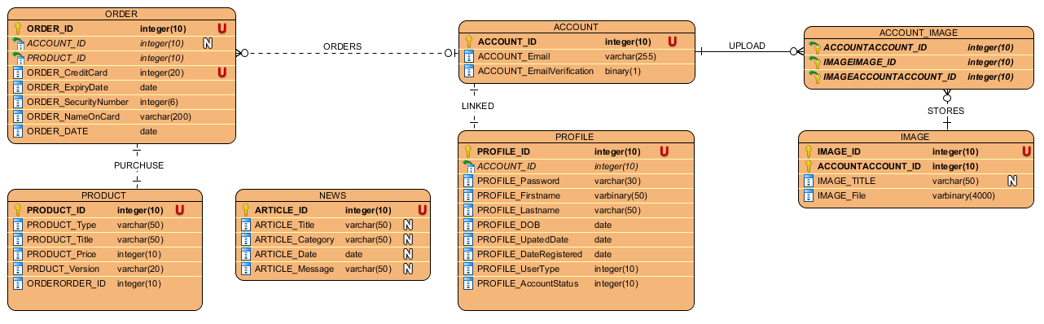

***Usability test result***

|  |  |  |  |  |  |
| --- | --- | --- | --- | --- | --- |
| Usability Test (Completed by 21600681 & 20700045) | | | | | |
| Item No. | **Test Item** | **Yes** | **No** | **N/A** | **Comments** |
| 1. | **The Website looks appealing.** |  |  |  | Admin panel delete row should have users input then just deleting last row. Home page needs more content. News should just merge with Home page. Account is fine. Login cool. Register cool. Buy now needs more data fields |
| 1a. | Navigation menu | x |  |  |
| 1b. | Home Page | x |  |  |
| 1c. | News Page | x |  |  |
| 1d. | Account Page | x |  |  |
| 1e. | Log in Page | x |  |  |
| 1f. | Register Page | x |  |  |
| 1g. | Buy Now Page | x |  |  |
| 1h. | Admin Panel | x |  |  |
| 2. | **The Website is simple to navigate.** | X |  |  | I can get to and from anywhere, menu is simple and easy to understand. new page does not exist. Could not access admin page as user. |
| 2a. | Navigation menu | X |  |  |
| 2b. | Account Page | X |  |  |
| 2c. | Log in Page | X |  |  |
| 2d. | Home page | X |  |  |
| 2e. | Register Page | X |  |  |
| 2f. | Buy now page | X |  |  |
| 2g. | New page |  |  |  |
| 2h. | Admin Panel | x |  |  |
| 3. | **Navigation bar is consistent on every page.** | X |  |  | Navbar is the same unless you login then login and register is removed. |
| 3a. | Home Page | X |  |  |
| 3b. | News Page | X |  |  |
| 3c. | Account Page |  | x |  |
| 3d. | Log-in Page | X |  |  |
| 3e. | Register Page | X |  |  |
| 3f. | Buy Now Page | X |  |  |
| 3g. | Admins Panel |  | x |  |
| 4. | **Text on each page is clear and easy to understand.** | x |  |  | Text is clear but I wish Home page had text inside a content box. |
| 4a. | Home Page | x |  |  |
| 4b. | News Page | x |  |  |
| 4c. | Accounts Page | x |  |  |
| 4d. | Log-in Page | x |  |  |
| 4e. | Buy Now Page | x |  |  |
| 4f. | Register Page | x |  |  |
| 4g. | Admin Panel | x |  |  |
| 5. | **The Website was informative of its purpose.** | X |  |  | Yes but more descriptive details could have been applied, so that I could email the developer for business. |
| 5a. | Home page was informative about the developers | x |  |  |
| 5b. | News Page was informative about upcoming events and news | x |  |  |
| 6. | **Navigation bar links are functional and take me to the correct place.** | X |  |  | Yes Navigation bar does link me to right page. |
| 6a. | Home Page | X |  |  |
| 6b. | News Page | X |  |  |
| 6c. | Log-In Page | X |  |  |
| 6d. | Register Page | x |  |  |
| 6e. | Account Page | x |  |  |
| 6f. | Buy now page | x |  |  |
| 7. | **Forms contain all required fields to fill out.** | X |  |  | Yes, though I personal with buy form had more input boxes like name and address. |
| 7a. | Log in page contains necessary form fields. | X |  |  |
| 7b. | Register page contains necessary form fields. | x |  |  |
| 7c. | Buy Now page contains necessary form fields. | x |  |  |
| 8. | **The website displays the expected pages required for its needs.** | X |  |  | Yes, but new page should be merged with home, and home should have a function to warrant its purpose. |
| 8a. | Home page | x |  |  |
| 8b. | News page | x |  |  |
| 8c. | Buy now page | x |  |  |
| 8d. | Register Page | x |  |  |
| 8e. | Account page | X |  |  |
| 9. | **All forms can be completed and submitted successfully.** |  | X |  | Forms are to be functional in second iteration of the assignment. |
| 9a. | Register form |  | X |  |
| 9b. | Buy Now Form |  | X |  |
| 9c. | Log in form |  | x |  |
| 10. | **Goals of the website look to have been achieved.** |  | X |  | Once functionality is implemented the goals will be achieved |
| 11. | **I would revisit this website for further use.** | X |  |  | If new content was to be created, and/or news patch updates |
| 12. | **Shop items priced fairly and labelled clearly.** | X |  |  | $10 for nothing, I have no visual idea what game you are trying to sell. |
| 12a. | 8-Bit Game | x |  |  |
| 13. | **Clickable buttons are obvious.** | X |  |  | Clickable links and buttons change colour on hover which is useful. They all look and “feel” like buttons |
| 13a. | Buy Now button | X |  |  |
| 13b. | Upload image | X |  |  |
| 13c. | Log out button | X |  |  |
| 13d. | Sign up button | x |  |  |
| 14. | **Information gathered from the user is relevant.** | X |  |  | Yes, there is no unnecessary want for my first and last name and zip code. |
| 14a. | Register form information | X |  |  |
| 14b. | Buy now form information | X |  |  |
| 14c. | Log in form information | x |  |  |